# Talent Profile page

### Note: While the competition project had a lot of pre-built functionality, the standard task project is almost entirely an empty shell. You will be required to implement all of the front-end and back-end functionality from scratch.

**Hint: Check the render() function of all the Components.**

[**Useful link**](https://developmentarc.gitbooks.io/react-indepth/content/life_cycle/birth/component_render.html)

### The Talent Profile page is a page for Talents to enter their personal details. Note: When you register an account, your password length has to be at least 8 characters.

* A main save button is not required for the components on the profile page.
* Each component will send an ajax call to the database.
* Display notifications at the top right corner of the page
  + Display a blue pop-up notification when profile data is successfully saved
  + Display a red pop-up notification when the input data doesn’t pass validation or when there is an error while saving

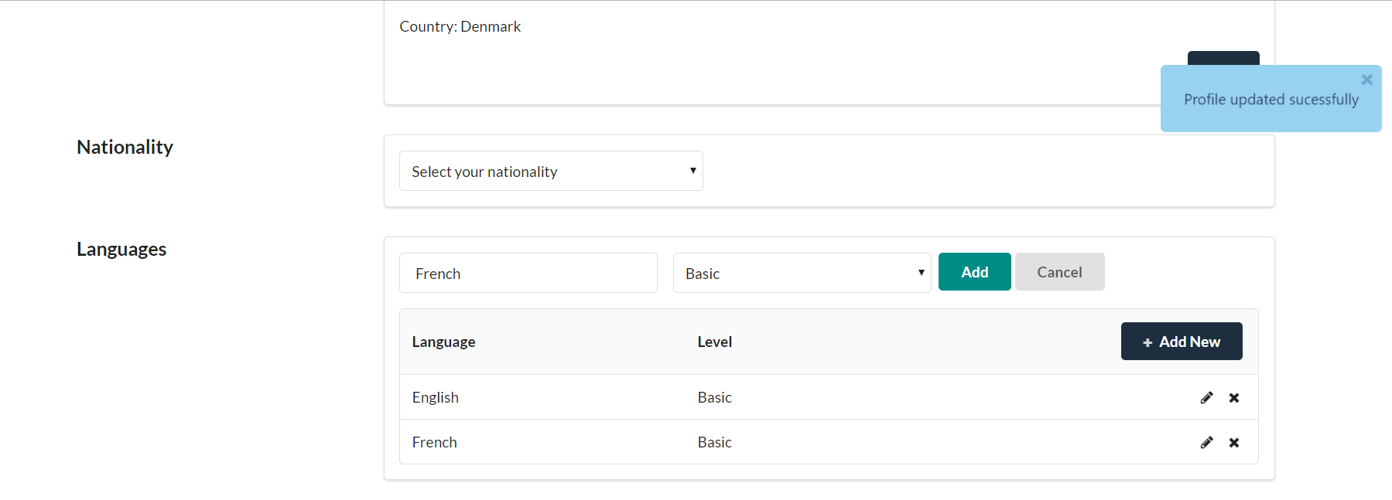

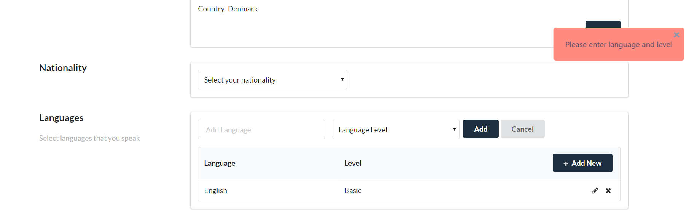

Linked Accounts Component

Read view:

Edit view:

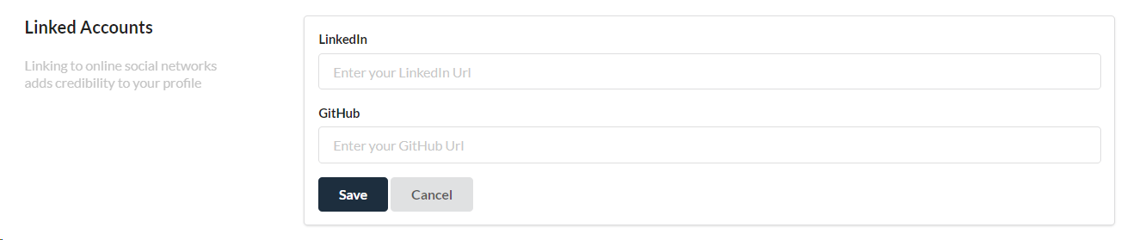

### Description

* Create a component that allows users to add a short summary and a description about themselves.

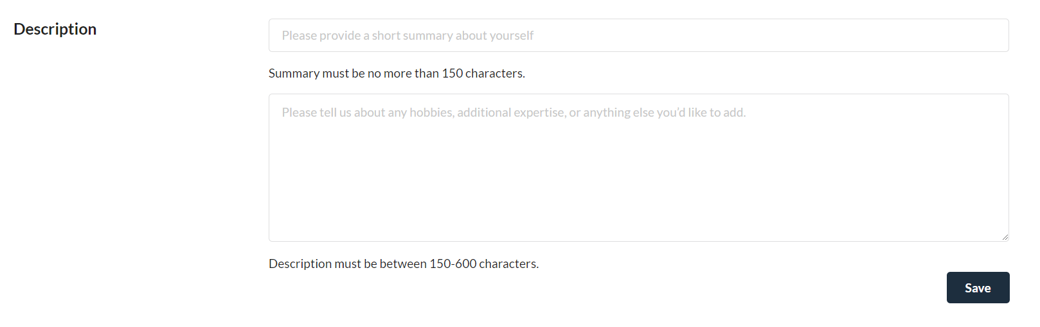

### User Details Component

* Create a component that allows the user to save their first name, last name, email address and phone number.
* Toggle between a display view and an edit view using the ‘Edit’ button

Read view:

1) No data

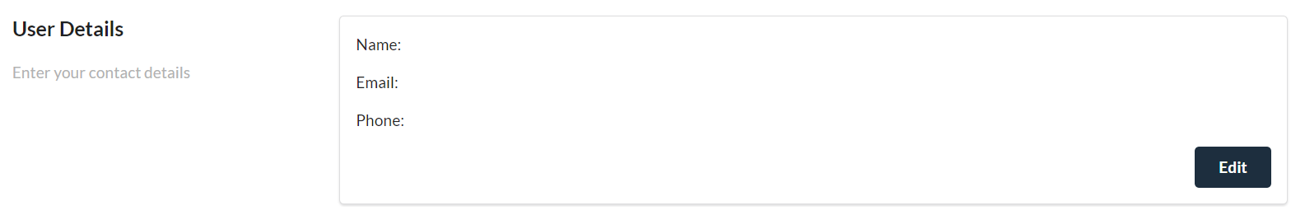

2) With data

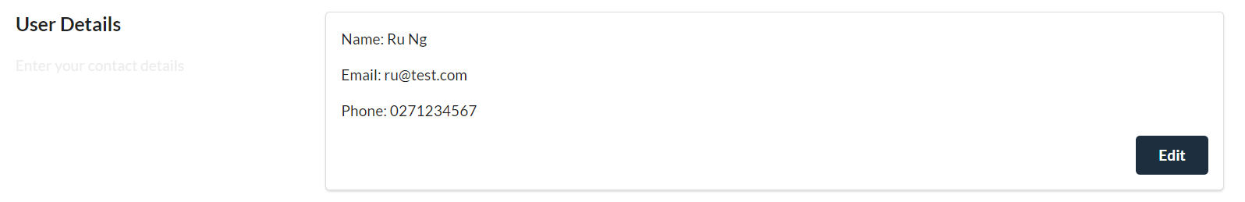

Edit view:

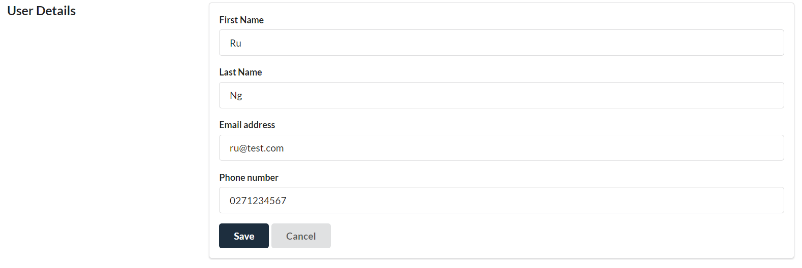

### 

### Address Component

* Create a component that allows users to select their Country and City using a dropdown and to enter their address number, street, suburb and postcode.
* Toggle between the Read and Edit view by clicking on the Edit button.

Dropdown Values

* For country and city, use values from countries.json
* File location: Talent.App.WebApp\wwwroot\util\jsonFiles\countries.json

Read view:

1) No data



2) With data

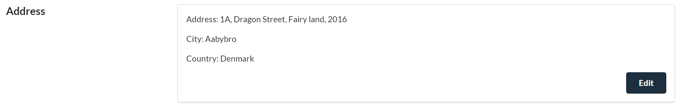

Edit view:

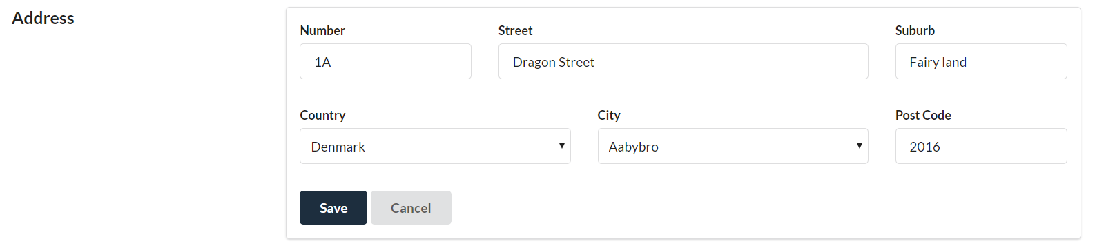

### 

Nationality Component

* Create a component that allows users to view and select their nationality

1) No data



2) With data



### Language Component

* Create a component that allows users to view and add/edit their languages and language proficiency

Dropdown Values

* Language Level:
  + Basic
  + Conversational
  + Fluent
  + Native/Bilingual

Overview:

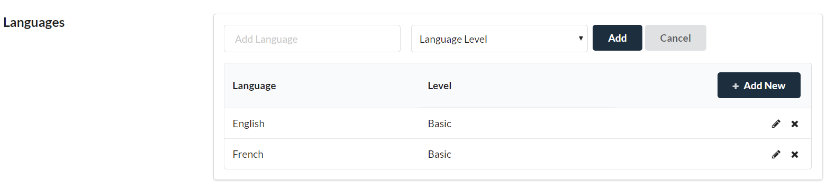

1) No data

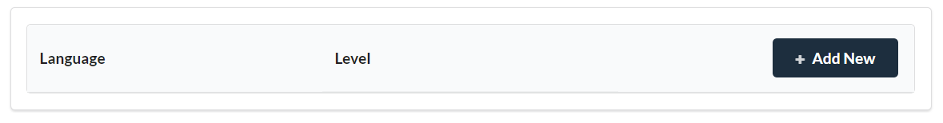

2) With data

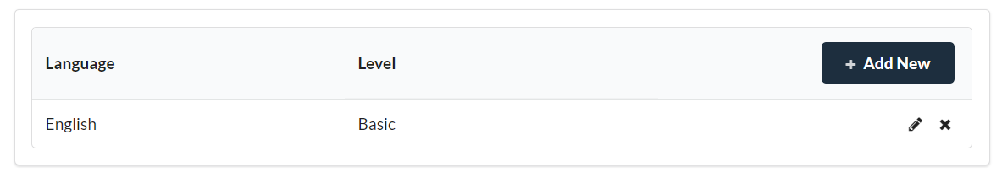

3) Click on [+ Add New] button to show ‘Add Language’ component

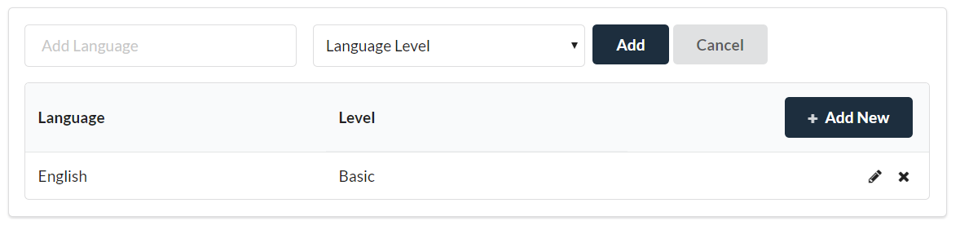

4) Click on [Cancel] button to hide ‘Add Language’ component



5) Click on [Pencil] icon to show ‘Update Language’ component

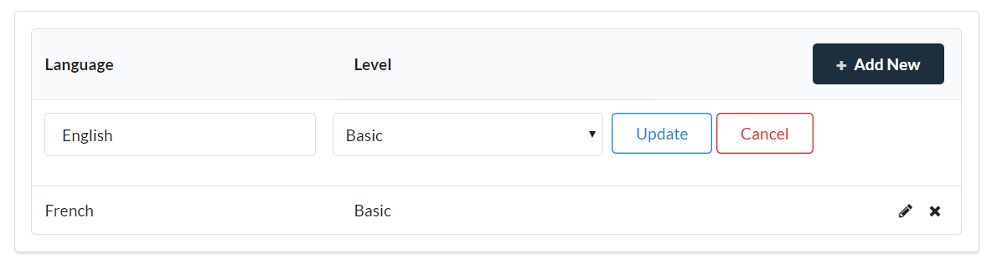

6) Click on [x] icon to delete Language

Skills Component

* Create a component that allows users to view and add/edit their languages and language proficiency

Dropdown Values

* Skill Level:
  + Beginner
  + Intermediate
  + Expert

1) No data

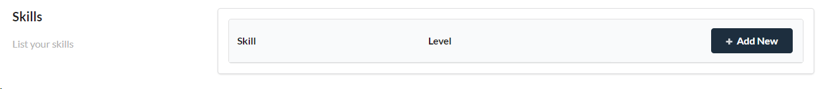

2) Click on [+ Add New] button to show ‘Add work experience’ component

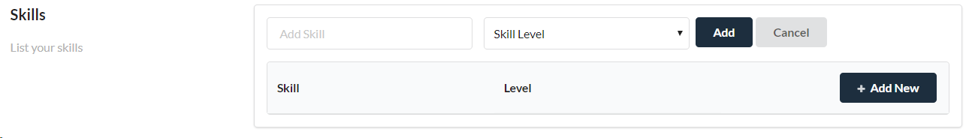

3) Click on [Add] button

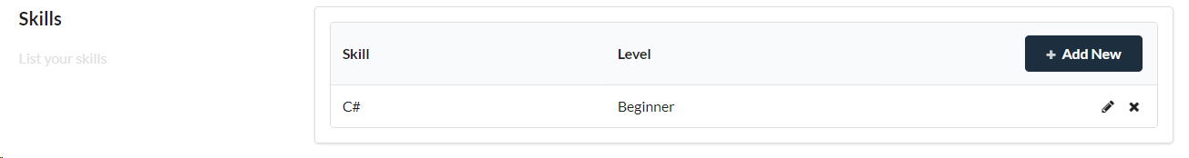

4) Click on [Pencil] icon to show ‘Update Skill’ component

5) Click on [x] icon to delete Skill

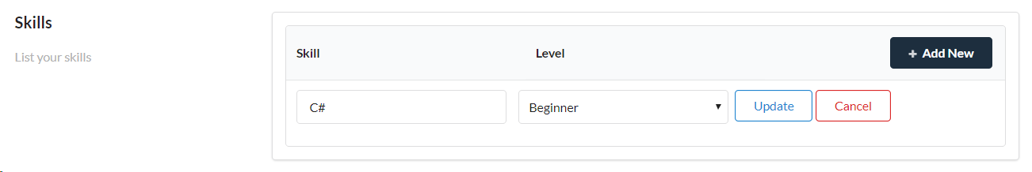

### 

### Work Experience Component

* Create a component that allows users to view and add/edit their work experience
* Start and end dates have to be displayed in the following format: 27th Aug, 2018

Overview:

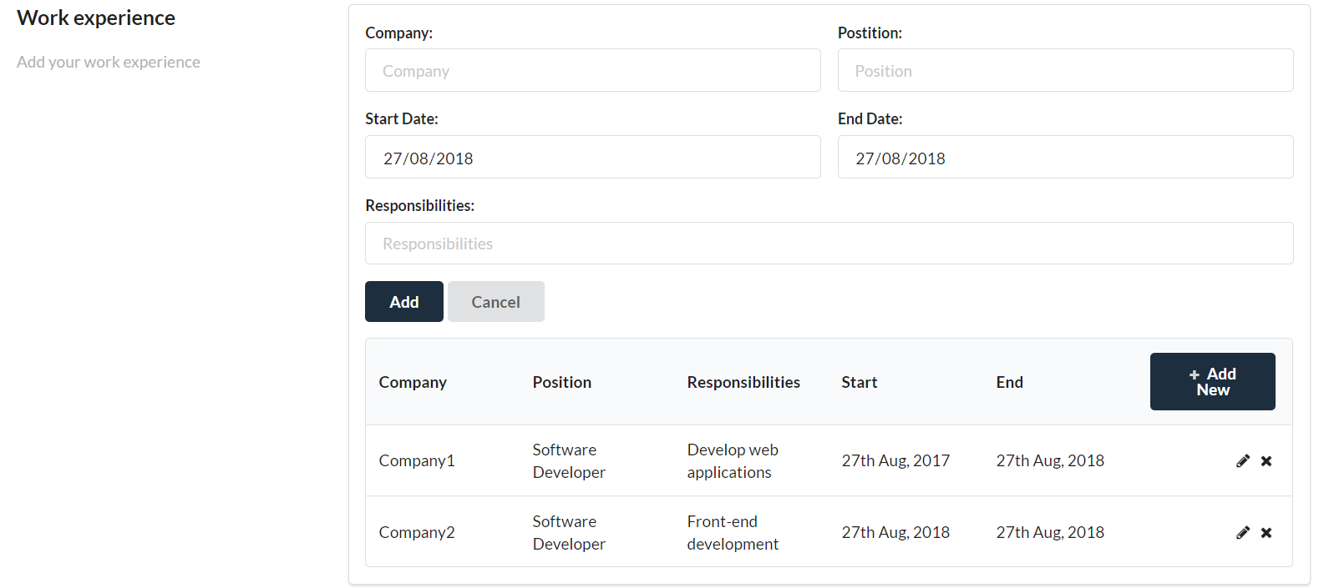

1) No data

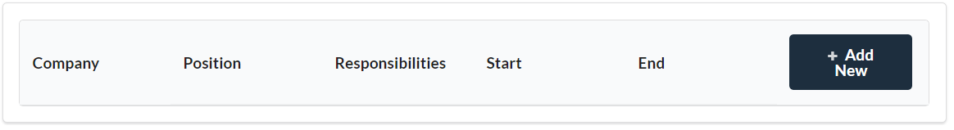

2) With data

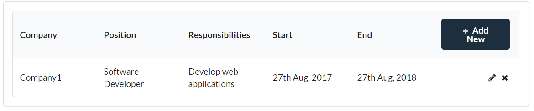

3) Click on [+ Add New] button to show ‘Add work experience’ component

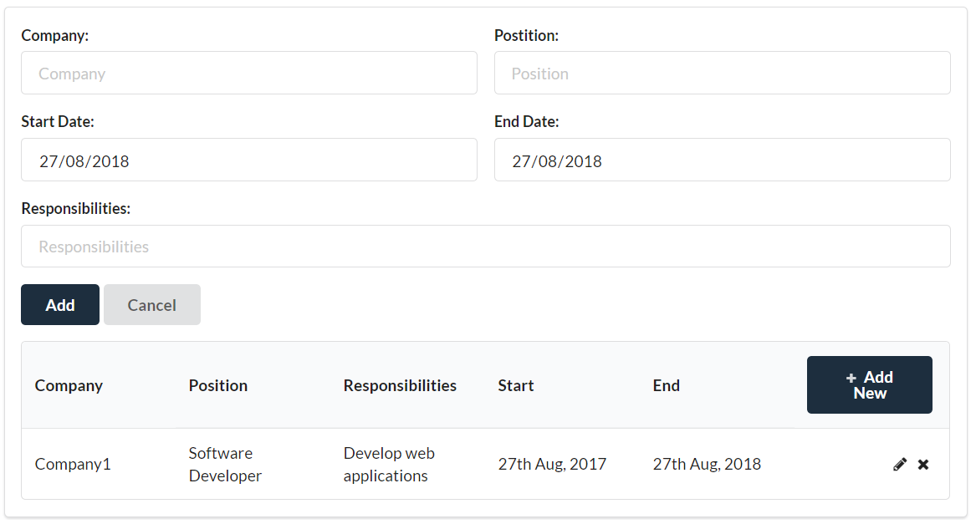

4) Click on [Cancel] button to hide ‘Add work experience’ component



5) Click on [Pencil] icon to show ‘Update Work Experience’ component

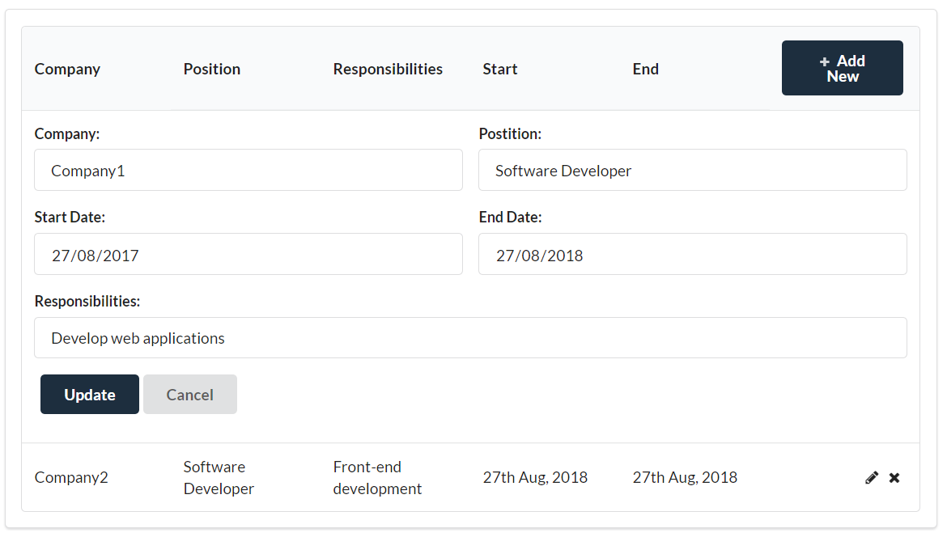

6) Click on [x] icon to delete work experience

### Visa Status Component

* Create a component that allows users to view and update their visa status

Dropdown Values

* Visa Type:
  + Citizen
  + Permanent Resident
  + Work Visa
  + Student Visa

1. If Visa Type is Citizen or Permanent Resident then hide the Visa expiry date input



1. If Visa Type is Work Visa or Student Visa then allow user to input the Visa expiry date

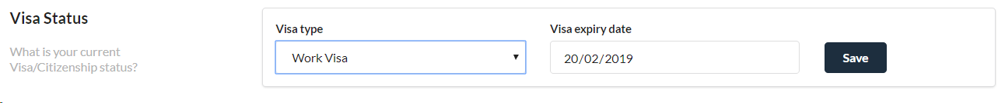

Job seeking status

* Create a component that allows users update their job seeking status  
  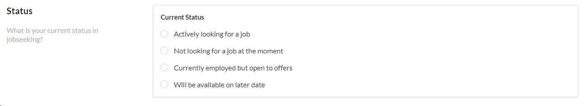

### 

### Profile Photo Component

* Create a component that allows users to view and upload their profile photo
* Check file types before saving to the database

1) Before uploading a profile photo (Display camera icon)



2) After clicking on the camera icon (Display file picker)

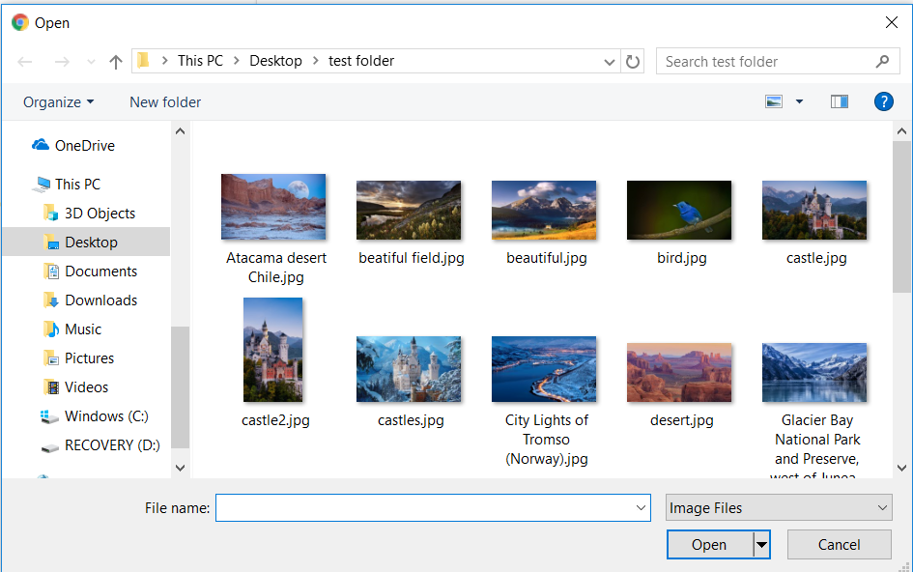

3) After selecting a picture (Display image thumbnail and upload button)

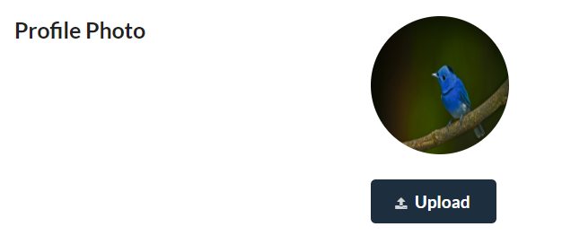

2) After saving the photo by clicking on the ‘Upload‘ button   
 (Display image thumbnail of uploaded image)

